**SHEET -5 – I/O REDIRECT,FILTERS(TEE,GREP,WC)**

Filters or text processor cmds.

1. Tee

a. To output.txt echo “Hello world” using tee cmd

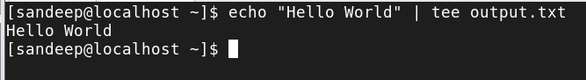

b. Run the cmd uname -a and append it to output.txt using tee -a cmd

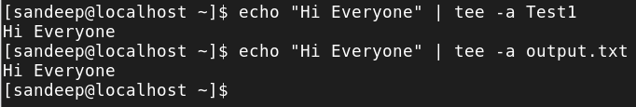

c. Run tac filename | tee Newfile | tac and observe. (tac is opposite of cat)

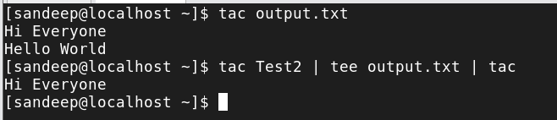

2. Grep

a. Create a text file named sample.txt with the following content Hello World Welcome to the world of Linux Learning commands is fun



b. Use grep cmd to find word ‘world’



c. Use grep cmd to find word ‘world’ case-insensitive

d. Use grep to count how many lines contain the word "Linux" in sample.txt (use grep -c “keyword” filename)

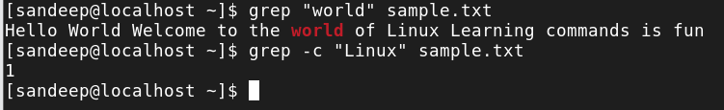

e. Use grep to display lines from sample.txt that do not contain the word "fun” (option -v)



f. Use egrep (extended grep) to find world and fun from sample.txt



g. Use ls -l | grep “keyword”

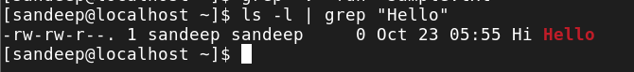

h. Cat /etc/passwd | grep “yourname”

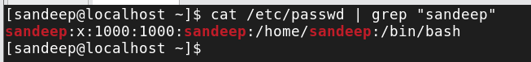

i.Create a directory named test_dir and place sample.txt and more_sample.txt inside it. Use grep to search for the word "World" recursively in the directory using grep -r "World" test_dir/

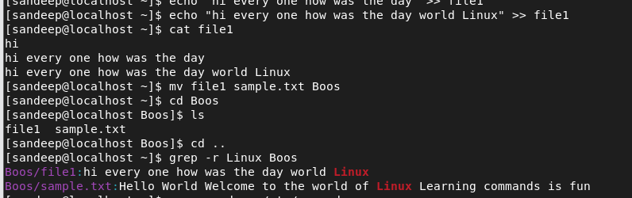

j. Try out the options grep -An , grep -Bn and grep -Cn

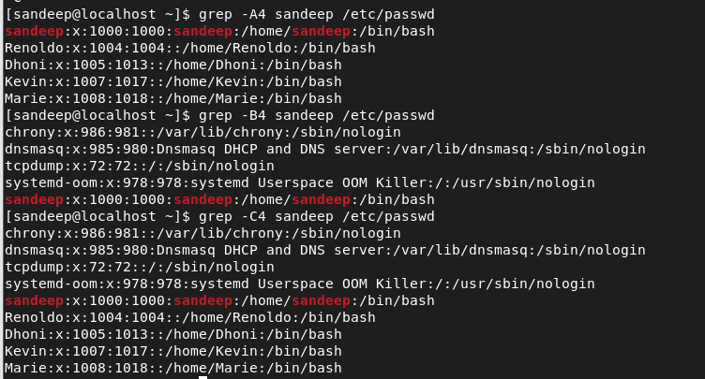

SHEET -5 FILTERS(TEE,GREP,WC)

3. Sort

i. Create a file with some contents and perform the following

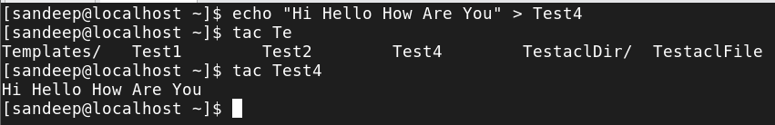

ii. Sort Filename , sort -r Filename ,sort -f filename ( -f = ignore case)

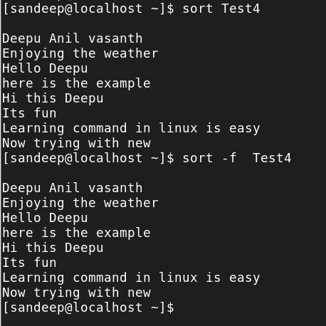

iii. Sort -k1 Filename (display column 1)

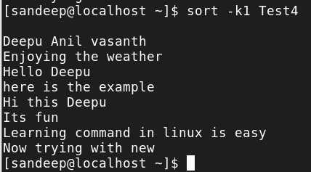

iv. Sort -nk3 Filename (sort numeric data and display col 3)

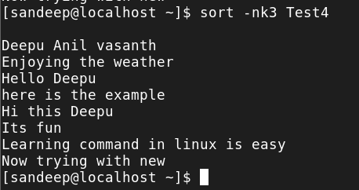

v. Sort -u Filename (sort and uniq)

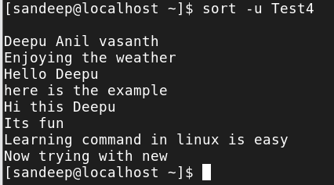

vi. Ls -l | sort -k9 | uniq

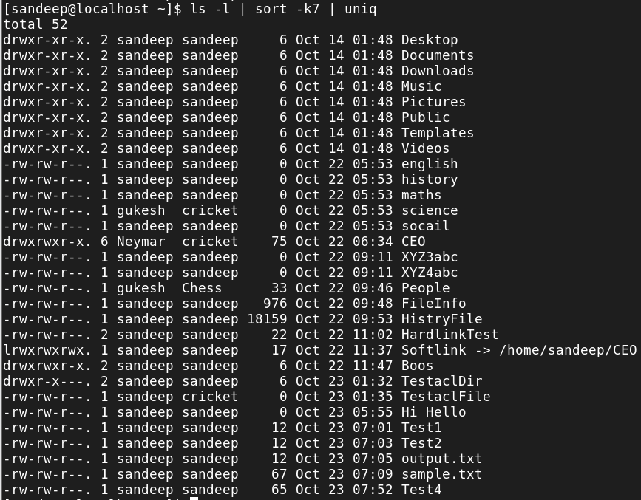

vii. Use cat file1 file2 | sort (enter some relevant text in file1 and file2)

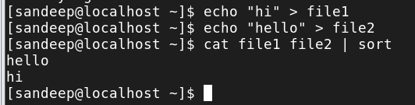

4. Uniq

i. Create a file with some duplicate contents and perform the following

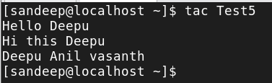

ii. Uniq filename

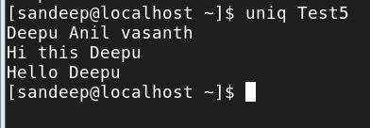

iii. Uniq -c filename

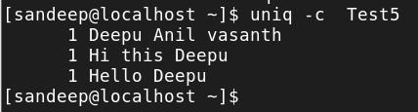

iv. Use it with sort cmd and redirect the o/p to a file. (sort filename | uniq > filename)

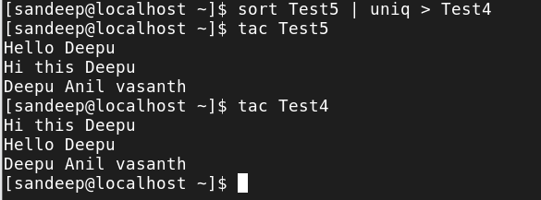

5. WC

i. Find the no of lines ,no of words and no. of chars in a file of your choice using wc cmd using wc filename ,wc -l ,wc -w ,wc -m

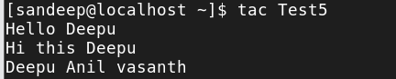

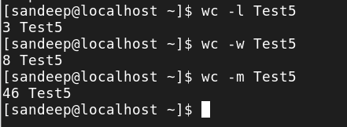

6. Cut

i. Create a text file named data.txt with the following content

John,25,Engineer

Alice,30,Designer

Bob,22,Developer

Charlie,28,Manager

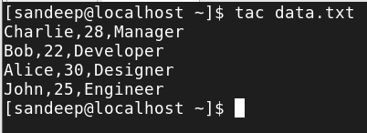

ii. Use cut to extract and display the first field.use -d and -f option

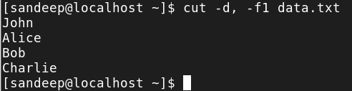

iii. Use cut to extract and display the names and ages (first and second fields)

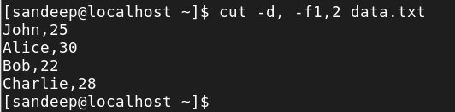

iv. Use cut to display the first 5 characters of each line in data.txt

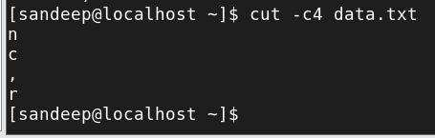

v. Use cut to extract the username in /etc/passwd file

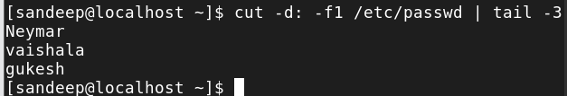

7. Awk

i. awk ‘{print $1}’ file = List 1st field from a file

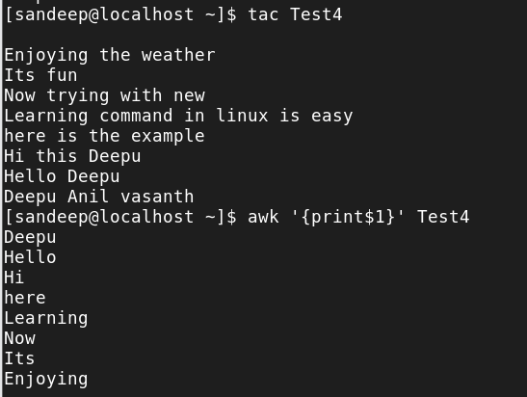

ii. ls –l | awk ‘{print $1,$3}’ = List 1 and 3rd field of ls –l output

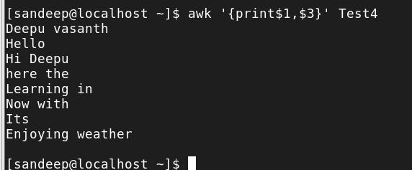

iii. ls –l | awk ‘{print $NF}’ = Last field of the output

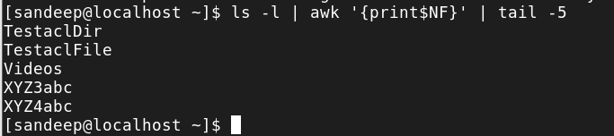

iv. awk '/keyword/ {print}' file = Search for a specific word

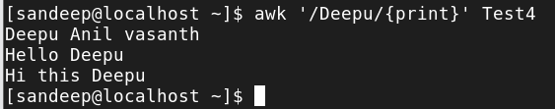

v. echo "Hello Tom" | awk '{$2="Adam"; print $0}‘ = Replace Tom with Adam